Experiment 10: Batch File Execution
Aim: To create and execute a batch file in Windows to automate the execution of commands.
Procedure:
- Open Notepad in Windows.
- Type the following commands into the text editor:
  - @echo off
  - echo Hello
  - pause
  - echo This is new
  - echo This is the second line ,pause
- Click File → Save As.
- Save the file with the name test.bat and select All Files as the file type.
- Locate the saved batch file and double-click it to execute.
- Observe the command prompt displaying the messages.
- Press any key when prompted to continue execution.
Screenshots:
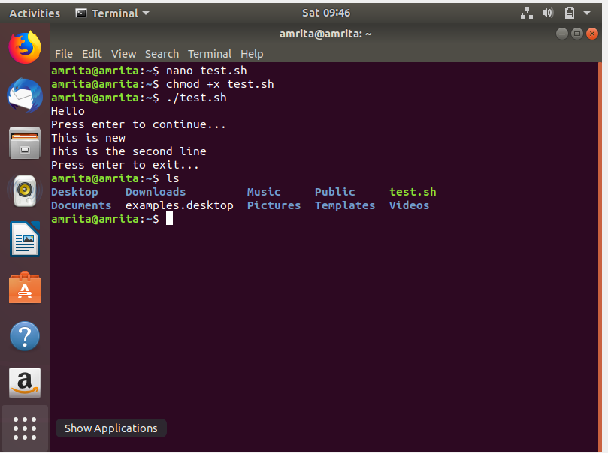
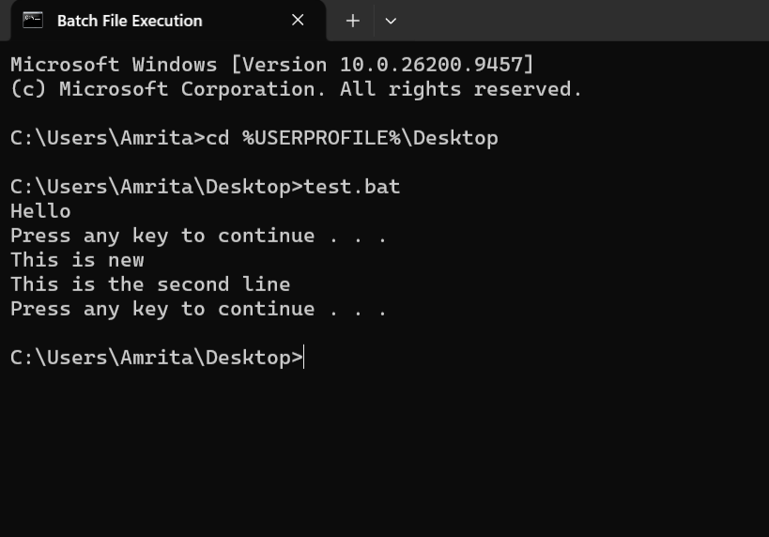

Result:
Thus, a batch file was created and executed successfully in Windows, demonstrating how multiple commands can be automated using a .bat file.

